SEARCHING ALGORITHM IN JAVA:

* **LINEAR SEARCH**

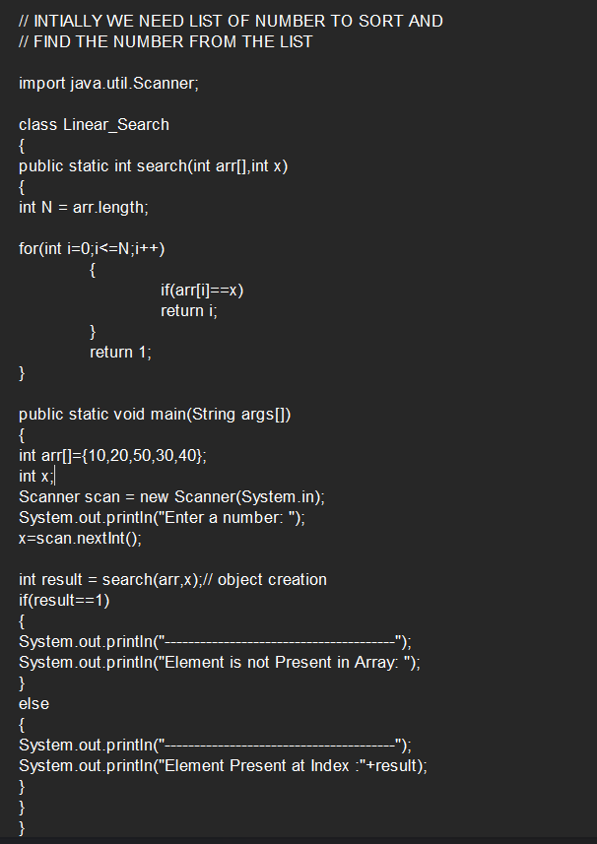

**OUTPUT:**

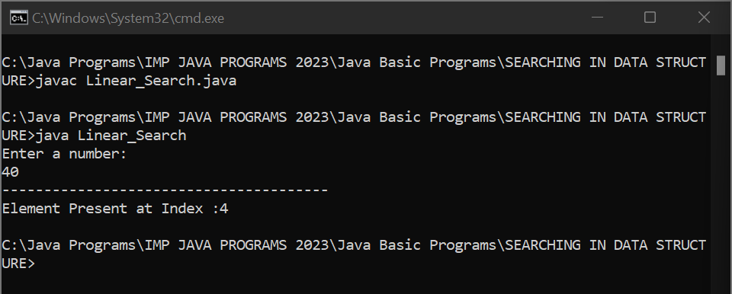

* BINARY SEARCH
* BREADTH FIRST SEARCH
* DEPTH FIRST SEARCH